**Name:**Swapnil Ghosh Group:A2 **Roll:**001911001067 **Subject:** Big Data

ASSIGNMENT 1

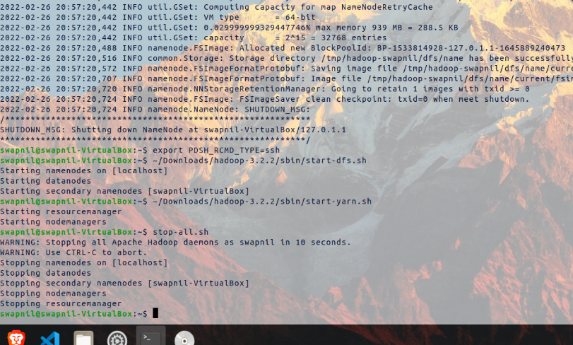

Hadoop Running on Ubuntu

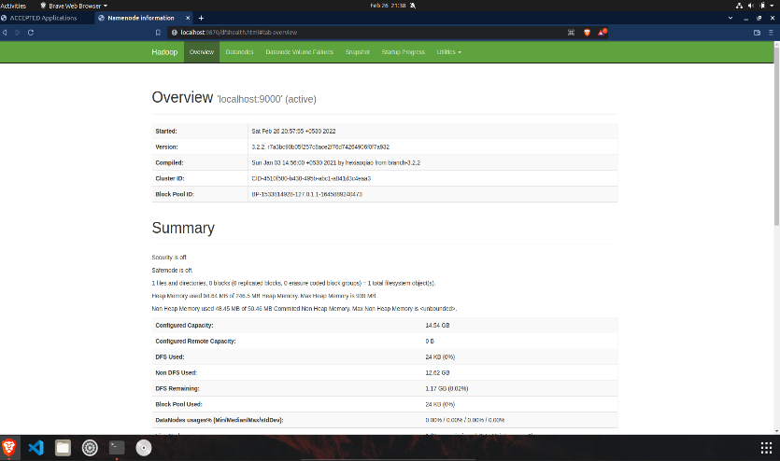

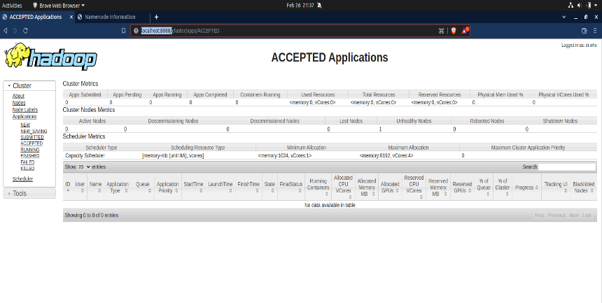 Overview Of The Cluster

YARN Panel